COMMUNITY CASE MANAGEMENT SERVICE (CCMS)
REFERRAL FORM

Agency for Integrated Care 5 Maxwell Road,#10-00 Tower Block,
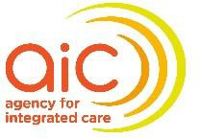
MND Complex Singapore 069110

Please email the completed referral form to CCMS Service Provider (refer to Annex A) and cc AIC (careconsultant@aic.sg)
Documents to be attached (if applicable): ☐ Latest doctor’s memo/Discharge Summary ☐ Social Report
- The Client and/or Caregiver has consented to be referred to CCMS and to the disclosure of enclosed information* to Agency for Integrated Care (AIC) and relevant agencies/service providers to facilitate the application and evaluation of the service?
*The client and/or caregiver has been informed that all information including individual’s Personal Data, financial, medical or social information, and any other information that is provided or allowed to access is subject to AIC’s Data Protection Policy (https://www.aic.sg/data-protection-policy).
1. CONSENT (PLEASE ✓)

2. REFERRAL SOURCE INFORMATION
Date of referral: | Referring organisation:
Referral Person: | Designation:
Contact No: | Email:

3. ELIGIBILITY CRITERIA
The eligibility criteria for CCMS are:  Elderly (aged 60 and above) and  - Meet at least 2 items from Domain A; or  - 1 item from Domain A and 1 item from Domain B; or  - 1 item from Domain A and 1 item from Domain C | Exclusion criteria:  - Need 24 hours care (e.g. bedbound) and have no caregiver  - Uncontrolled psychiatric disorders and/or behavioural problems  - Already enrolled into other case
 | management programmes
Please ✓ the number of item(s) met for each eligibility domain below:
Domain A: Psycho-social impairment
- No caregiver/caregiver issues (e.g., caregiver unable to cope, caregiver is unable to care for client); or
- Family/ domestic issues (e.g., neglect, mistreated, abused); or
- Social isolation/ low mood (e.g. withdrawal from interest and family, anxious, depressed or self-injurious ideation); or
- Require review on environmental safety/ unstable housing arrangement (e.g. hoarding, cluttering, needs home improvement).

Domain B: Complex medical issues
- Poorly controlled chronic condition(s)¹ or advanced disease(s)², which requires assistance and monitoring.
Domain C: Functional impairment
- Physical, mental or cognitive impairment affecting Activities of Daily Living (ADL) and/or Instrumental Activities of Daily Living (IADL) or behaviour, which require coordination of services to remain in the community.

Reasons for referral to CCMS:

- “Poorly controlled chronic condition(s)” refers to chronic disease(s) that has (have) not met acceptable treatment targets which resulted in active symptoms affecting the well-being or general condition of the person; or that may result in long term complications.
- “Advanced disease(s)” refers to disease(s) at later phases of the disease trajectory whereby typically there is a high symptom burden, functional loss and/or poor prognosis. E.g. end-
stage organ failure, late-stage neurological disorder like dementia.

4. CLIENT’S PARTICULARS
Full Name: |  |  | NRIC:
Gender: ☐ Male ☐ Female |  | Date of Birth: (dd/mm/yyyy) | Age: | Citizenship:  - Singapore ☐ Singapore PR  - Others:
Residential Address:  Postal Code: |  |  | Contact No:  - Home:  - Mobile:
Home Ownership: | - Rental ☐ Purchased ☐ Lodging
Housing Type: | - HDB No of Rooms ☐ 1 ☐ 2 ☐ 3 ☐ 4 ☐ 5 ☐ Others:  - Private
Marital Status: | - Single ☐ Married ☐ Widowed ☐ Separated ☐ Divorced
Race | - Chinese ☐ Malay ☐ Indian ☐ Eurasian ☐ Others:
Language Spoken: | - English ☐ Mandarin ☐ Malay ☐ Tamil ☐ Others:
If client is hospitalised at the point of referral, please indicate estimated hospital discharge date:
5. HEALTH INFORMATION (Attach doctor’s memo or discharge summary if available)
(May include summary of medical conditions/problems, functional status, investigations and management to date etc.)
Visual Impairment: ☐ Yes ☐ No  If Yes, Specify: |  |  | Hearing Impairment: ☐ Yes ☐ No  Using Hearing Aid: ☐ Yes ☐ No
Any Behavioural Issues (e.g. violent, aggressive, hallucination)? ☐ No ☐ Yes (Specify):
Current Mental State: ☐ Rational ☐ Confused ☐ Unable to respond ☐ Others:
Does client currently have any active infectious disease?
- Unsure ☐ No ☐ Yes (specify): Precaution: ☐ Standard ☐ Contact ☐ Others

Are there any other precautions to be taken or conditions that would require close monitoring?
- Unsure ☐ No ☐ Yes (specify):
6. SOCIAL INFORMATION (Attach social report if available)
(May include info such as family set-up, social support and issues, caregiver, living arrangement, main spokesperson, significant family dynamics and genogram etc.)
7. FINANCIAL INFORMATION
Assistance Type:  - None ☐ PA ☐ ComCare ☐ Medifund  - Medical Fee Exemption Card (MFEC)  - Others: |  |  | Other Sources of Financial Support:  E.g. Family, Religious Groups, Foundations, etc.  Source:

Household Means Test Completed (Non-Residential MOH ILTC) : ☐ Yes ☐ No ☐ N/A
If Yes, please state Subsidy Level : Valid until:
At present, is the client receiving any kind of community support?
(State agencies or individuals supporting the senior E.g. neighbours, friends, meals delivery, medical escort, Active Ageing Centres, Centre-based care, Home Care, etc.)

- No ☐ Yes (specify):
8. EXISTING COMMUNITY SUPPORT

9. NEXT OF KIN OR | CAREGIVER’S PARTICULARS
Name: |  | Relationship to Client:
Contact No: ☐ Home: | - Mobile: | Language Spoken:
Additional Information:
10. OTHER RELEVANT INFORMATION

ANNEX A: List of CCMS providers, service boundaries and contact details.
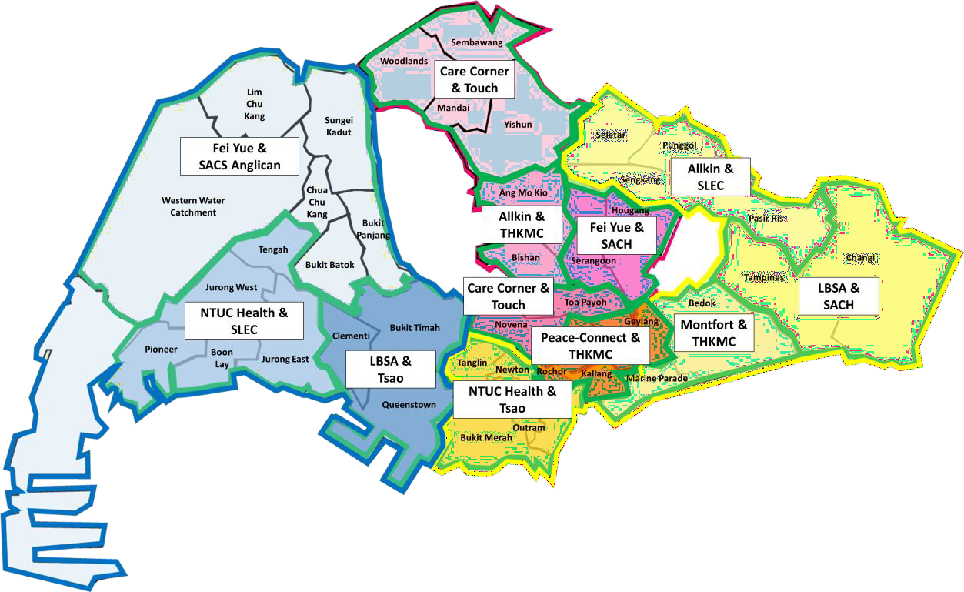

(Annex A)
There are 2 CCMS Providers serving each service boundary.
Referral sources should only select 1 CCMS Provider to refer to.

Service Boundaries (URA Planning Areas) |  | CCMS Service Provider | Contact Details
- Bukit Batok  - Bukit Panjang  - Choa Chu Kang | - Lim Chu Kang  - Sungai Kadut  - Western Water Catchment | Fei Yue Community Services (FYCS) | - Email: feiyue_ccms@fycs.org  - Contact: 6378 0801
- Bukit Batok  - Bukit Panjang  - Choa Chu Kang | - Lim Chu Kang  - Sungai Kadut  - Western Water Catchment | Singapore Anglican Community Services (SACS) | - Email: ccms_je@sacs.org.sg  - Contact: 6262 1183
- Boon Lay  - Jurong East  - Jurong West | - Pioneer  - Tengah | St Luke’s Eldercare Ltd (SLEC) | - Email: ccms@slec.org.sg  - Contact: 9740 5030
- Boon Lay  - Jurong East  - Jurong West |  | NTUC Health Co-Operative Ltd | - Email: ccms@ntuchealth.sg  - Contact: 8612 8302
- Bukit Timah  - Clementi  - Queenstown |  | Tsao Foundation | - Email: hmccms@tsaofoundation.org  - Contact: 6593 9595
 |  | Lions Befrienders Service Association  (LBSA) | - Email: ccms.west@lb.org.sg  - Contact: 6681 4020
- Mandai  - Sembawang  - Woodlands  - Yishun |  | Care Corner Seniors Services Ltd | - Email: ccms@carecorner.org.sg  - Contact: 6570 3919
 |  | TOUCH Community Services Limited | - Email: ccms@touch.org.sg  - Contact: 6481 5031
- Ang Mo Kio  - Bishan |  | Allkin Singapore Ltd | - Email: refer2seniorservice@allkin.org.sg  - Contact: 6038 4310
 |  | Thye Hua Kwan Moral Charities Limited (THKMC) | - Email: thkccms-amk@thkmc.org.sg  - Contact: 6556 4833
- Hougang  - Serangoon |  | St Andrew’s Community Hospital (SACH) | - Email: gp_sascccms@sasc.org.sg  - Contact: 6320 0535
 |  | Fei Yue Community Services (FYCS) | - Email: feiyue_ccms@fycs.org  - Contact: 6378 0801
- Novena  - Toa Payoh |  | Care Corner Seniors Services Ltd | - Email: ccms@carecorner.org.sg  - Contact: 6570 3919
 |  | TOUCH Community Services Limited | - Email: ccms@touch.org.sg  - Contact: 6481 5031
- Geylang  - Kallang  - Rochor |  | Peace-Connect Cluster Operator (PeCCO) | - Email: aco_pecco@sacs.org.sg  - Contact: 6291 2491
 |  | Thye Hua Kwan Moral Charities Limited (THKMC) | - Email: thkccms-geylang@thkmc.org.sg  - Contact: 6846 1228
- Bukit Merah  - Downtown Core  - Newton  - Orchard | - Outram  - River Valley  - Singapore River  - Tanglin | Tsao Foundation | - Email: hmccms@tsaofoundation.org  - Contact: 6593 9595
- Bukit Merah  - Downtown Core  - Newton  - Orchard | - Outram  - River Valley  - Singapore River  - Tanglin | NTUC Health Co-Operative Ltd | - Email: ccms@ntuchealth.sg  - Contact: 8612 8302
- Bedok  - Marine Parade |  | Montfort Care | - Email: ccms.east@montfortcare.org.sg  - Contact: 9710 1614
 |  | Thye Hua Kwan Moral Charities Limited (THKMC) | - Email: thkccms-bedok@thkmc.org.sg  - Contact: 6241 8171
- Changi  - Tampines |  | St Andrew’s Community Hospital (SACH) | - Email: gp_sascccms@sasc.org.sg  - Contact: 6320 0535
 |  | Lions Befrienders Service Association  (LBSA) | - Email: ccms.east@lb.org.sg  - Contact: 6681 4939
- Pasir Ris  - Punggol  - Seletar  - Sengkang |  | Allkin Singapore Ltd | - Email: refer2seniorservice@allkin.org.sg  - Contact: 6038 4310
 |  | St Luke’s Eldercare Ltd (SLEC) | - Email: ccms@slec.org.sg  - Contact: 9740 5030

